Filename: **program**

program

int a, b, c;

double d;

begin

a = 3*(5+2);

b = (3 + 4) * 5;

c = a;

print a;

print b;

print c;

print (2+3)*7 + 2^3;

end

Result:

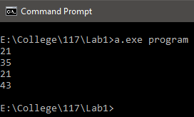

Filename: **SemanticError**

program

int a;

begin

a = hello;

end

Result:

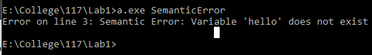

Filename: **SemanticError2**

program

float b;

begin

b = 3.3;

end

Result:

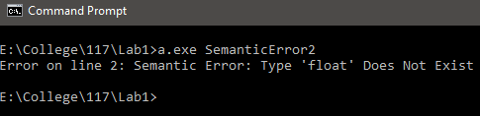

Filename: **SyntaxError**

program

int a;

begin

a = 5

end

Result:

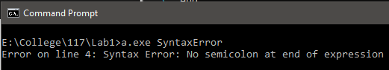

Filename: **SyntaxError2**

program

int a, b;

begin

a = 5;

b = 2 * 5;

print;

end

Result:

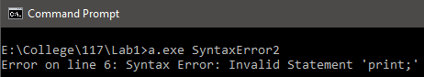

Filename **LexicalError**

program

int 12|&, b;

begin

12|& = 5;

b = 2 * 5;

end

**Result**



**Filename LexicalError2**

program

&*@&

int a, b;

begin

a = 5;

b = 2 * 5;

end

Result

